prEN 00019539:2018 (E) 511Produits pétroliers — Distillation des produits pétroliers et de combustibles liquides à la pression atmosphérique — Méthode Micro DistillationFlüssige Mineralölerzeugnisse — Bestimmung der Destillationseigenschaften bei atmosphärischem Druck — MikrodestillationLiquid petroleum products — Determination of distillation characteristics at atmospheric pressure — Micro-distillationE0 00 201805CEN EnquiryCEN 1European StandardEuropean StandardEN 00019539prEN 00019539:2018 0Falsch 00019539NENGaseous and liquid fuels, lubricants and related products of petroleum, synthetic and biological origin19 2Überschrift 2Überschrift 1 0 STD Version 2.9d40 1X:\TA1\TG1-5\NA 062\DIN\NA 062-06 FB\Projekte\EN-Normen\WI_00019539 (ehemals 00019472)\gir_ 0_PMD100 CEN test method draft 2018_05_27.doc.docx CEN/TC 19

Date: 2021-09

prEN 17306:2021

CEN/TC 19

Secretariat: NEN

Liquid petroleum products — Determination of distillation characteristics at atmospheric pressure — Micro-distillation

*Flüssige* Mineralölerzeugnisse *— Bestimmung der Destillationseigenschaften bei atmosphärischem Druck — Mikrodestillation*

*Produits* pétroliers *— Distillation des produits pétroliers et de combustibles liquides à la pression atmosphérique — Méthode Micro Distillation*

ICS: 75.080; 75.160.20

Descriptors: petroleum products, middle distillates, middle distillate fuels, diesel, oils, testing, petroleum, fuels, derivative of oil, petroleum technology, petroleum industry,

Contents Page

European foreword 3

Introduction 4

1 Scope 5

2 Normative references 5

3 Terms and definitions 5

4 Principle 7

5 Reagents and materials 7

6 Apparatus 7

6.1 Micro distillation unit 7

6.2 Barometer for calibration 8

6.3 Sampling device 8

6.4 Waste beaker 8

7 Sampling 8

8 Apparatus preparation 9

9 Calibration, verification and quality control 9

9.1 General 9

9.2 Calibration 9

9.3 Instrument verification 9

9.4 Quality control 10

10 Procedure 10

11 Calculation 11

12 Expression of results 11

13 Precision 11

13.1 General 11

13.2 Repeatability, *r* 12

13.3 Reproducibility, *R* 13

13.4 Bias 13

13.5 Relative bias 15

13.6 Repeatability and reproducibility for FAME 16

13.7 Relative bias for FAME 16

14 Test report 17

Annex A (normative) Micro distillation apparatus 18

A.1 Detailed description of apparatus 18

Annex B (normative) Precision of the volume percent evaporated or recovered at a prescribed temperature 21

Annex C (informative) Typical samples 22

Bibliography 23

European foreword

This document (prEN 17306:2022) has been prepared by Technical Committee CEN/TC 19 “Gaseous and liquid fuels, lubricants and related products of petroleum, synthetic and biological origin”, the secretariat of which is held by NEN.

This document is currently submitted to the CEN Enquiry.

This document will supersede EN 17306:2019.

In comparison with the previous edition, a bias correction explanation has been introduced, which has no effect on the method precision.

Introduction

The distillation (volatility) characteristics of hydrocarbons and other liquids have an important effect on their safety and performance, especially in the case of fuels and solvents. The boiling range gives information on the composition, the properties, and the behaviour of the fuel during storage and use. Volatility is the major determinant of the tendency of a hydrocarbon mixture to produce potentially explosive vapours.

The distillation characteristics are critically important for both automotive and aviation gasolines, affecting starting, warm-up and tendency to vapour lock at high operating temperature or at high altitude, or both. The presence of high boiling point components in these and other fuels can significantly affect the degree of formation of solid combustion deposits.

Distillation limits are often included in petroleum product specifications, in commercial contract agreements, process refinery/control applications, and for compliance to regulatory rules.

This test method can be applied to contaminated products or hydrocarbon mixtures. This is valuable for fast product quality screening, refining process monitoring, fuel adulteration control, or other purposes including use as a portable apparatus for field testing.

This document is as of the time of publication technically equivalent to ASTM D7345 [1], on which it is based.

This test method uses an automatic micro distillation apparatus, provides fast results using small sample volume, and eliminates much of the operator time and subjectivity in comparison to EN ISO 3405 or ASTM D1160 [2].

# Scope

This document specifies a laboratory method for the determination of the distillation characteristics of light and middle distillates derived from petroleum and related products of synthetic or biological origin with initial boiling points above 20 °C and end-points below approximately 400 °C, at atmospheric pressure utilizing an automatic micro distillation apparatus.

This test method is applicable to such products as light and middle distillates, automotive spark-ignition engine fuels, automotive spark-ignition engine fuels containing up to 20 % (*V/V*) ethanol, aviation gasolines, aviation turbine fuels, (paraffinic) diesel fuels, FAME (B100), diesel blends up to 30 % (*V/V*) fatty acid methyl esters (FAME), special petroleum spirits, naphtha’s, white spirits, kerosene’s, burner fuels, and marine fuels.

The test method is also applicable to hydrocarbons with a narrow boiling range, like organic solvents or oxygenated compounds.

The test method is designed for the analysis of distillate products; it is not applicable to products containing appreciable quantities of residual material.

**WARNING** — The use of this document can involve hazardous materials, operations and equipment. This document does not purport to address all of the safety problems associated with its use. It is the responsibility of user of this document to take appropriate measures to ensure the safety and health of personnel prior to application of the document, and to fulfil statutory and regulatory requirements for this purpose.

NOTE For the purpose of this document, the expression “% (*V/V*)” is used to represent the volume fraction.

# Normative references

The following documents are referred to in the text in such a way that some or all of their content constitutes requirements of this document. For dated references, only the edition cited applies. For undated references, the latest edition of the referenced document (including any amendments) applies.

EN ISO 3170, Petroleum liquids - Manual sampling (ISO 3170)

EN ISO 3171, Petroleum liquids - Automatic pipeline sampling (ISO 3171)

EN ISO 3405, Petroleum and related products from natural or synthetic sources - Determination of distillation characteristics at atmospheric pressure (ISO 3405)

EN ISO 4259‑1, Petroleum and related products - Precision of measurement methods and results - Part 1: Determination of precision data in relation to methods of test (ISO 4259-1)

# Terms and definitions

For the purposes of this document, the following terms and definitions apply.

ISO and IEC maintain terminological databases for use in standardization at the following addresses:

— IEC Electropedia: available at <https://www.electropedia.org/>

— ISO Online browsing platform: available at <https://www.iso.org/obp>

3.1

automatic apparatus

microprocessor-controlled unit that performs the procedures of automatically controlling the evaporation of a liquid specimen under specific conditions of this test method, collecting measurement data and converting this data by patented algorithm in order to predict distillation results in correlation with industry recognized reference method

3.2

corrected temperature reading

temperature readings, corrected to 101,3 kPa barometric pressure

3.3

end point

final boiling point

FBP

maximum thermometer reading (corrected) obtained during the test

Note 1 to entry: This usually occurs after the evaporation of all liquid from the bottom of the distillation flask.

Note 2 to entry: The term maximum temperature is a frequently used synonym.

3.4

flask internal pressure

pressure within the distillation flask obtained during the test by a differential pressure sensor of automatic apparatus

Note 1 to entry: The flask internal pressure data recorded during the test is automatically converted to the volume percent recovered or evaporated data by patented algorithm employed by automatic apparatus.

3.5

initial boiling point

IBP

corrected temperature readings that corresponds to the instant of the flask internal pressure rise observed

3.6

liquid temperature

temperature of the liquid specimen in the distillation flask during the test obtained by a liquid temperature measuring device of automatic apparatus

3.7

percent recovered

volume of condensate observed by the automatic apparatus at any point in the distillation, expressed as a percentage of the charge volume, in connection with a simultaneous temperature reading

3.8

percent recovery

recovery predicted by the automatic apparatus and expressed as a percentage of the charge volume

3.9

percent residue

volume of residue in the distillation flask expressed as a percentage of the charge volume

3.10

reference method

test method or its analogues which is widely used for expression of the distillation characteristics of petroleum products in industry

3.11

temperature reading

adjusted vapour and liquid temperature by using an algorithm of the automatic apparatus to mimic the same temperature lag and emergent stem effects as would be seen when using a liquid-in-glass thermometer to determine the distillation characteristics

3.12

vapour temperature

temperature of the vapour in the distillation flask during the test obtained by a vapour temperature measuring device of automatic apparatus

# Principle

A sample is transferred into the distillation flask, the distillation flask is placed into position on the automatic apparatus, and heat is applied to the bottom of the distillation flask.

The automatic apparatus measures and records sample vapour and liquid temperatures, and pressure in the distillation flask as the sample gradually distils under atmospheric pressure conditions. Automatic recordings are made throughout the distillation and the data stored into the apparatus memory.

At the conclusion of the distillation, the collected data are treated by the data processing system, converted to distillation characteristics and corrected for barometric pressure.

Test results are commonly expressed as percent recovered or evaporated versus corresponding temperature in compliance with industry recognized standard form and reference method either in a table or graphically, as a plot of the distillation curve.

# Reagents and materials

**5.1 Cleaning solvents**, suitable for cleaning and drying the test flask such as; petroleum naphtha and acetone.

**5.2 Toluene,** 99,5 % purity.

**5.3 n-Hexadecane**, 99 % purity.

**5.4 Chemicals** of at least 99 % purity shall be used in the calibration procedure (see 9.3).

**5.5 Granular pumice stones**, clean and dry fine grade pumice stones of diameter 0,8 mm to 3,0 mm, approximately 10 grains are necessary for each test.

**5.6 Sample drying agent**, Anhydrous sodium sulphate has been found to be suitable.

# Apparatus

## Micro distillation unit

The basic components of the micro distillation unit are the distillation flask, a condensate recovery area with waste beaker, an enclosure for the distillation flask with the heat source and flask support, the specimen liquid temperature measuring device, the specimen vapour temperature measuring device, the distillation flask internal pressure measuring device, the ambient pressure measuring device, the control systems for regulating the distillation process, and the data processing system for converting recorded information into typical industry recognized standard report form.

A detailed description of the apparatus is given in Annex A.

## Barometer for calibration

A pressure measuring device capable of measuring local station pressure with an accuracy of 0,1 kPa (or better, at the same elevation relative to sea level where the apparatus is located.

**WARNING — The barometer is only required for periodic calibration of the ambient pressure measuring devices. Do not take readings from ordinary aneroid barometers, such as those used at weather stations and airports, since these are pre-corrected to give sea level readings.)**

## Sampling device

Glass or plastics syringe capacity (10 ± 0,3) ml or constant volume dispenser capacity (10 ± 0,3) ml.

## Waste beaker

Glass approximately 200 ml capacity, outside diameter approximately 70 mm and height approximately 130 mm fitted with a cover to reduce evaporation. The cover design shall allow the beaker to remain open to atmospheric pressure.

# Sampling

**7.1** Unless otherwise specified, samples shall be taken as described in EN ISO 3170 or EN ISO 3171, whereas requirements of national regulations for the sampling of the product under test should be taken into account. At least 50 ml of sample is recommended.

**7.2** The extreme sensitivity of volatility measurements to losses through evaporation and the resulting changes in composition is such as to require the utmost precaution in the drawing and handling of volatile product samples.

**7.3** Sample shall be free from any suspended solids or other insoluble contaminations. Obtain another sample or remove solid particle by filtration. During filtration operation take care to minimize any loss of light ends.

**7.4** All samples shall be stored in a tightly closed and leak-free container away from direct sunlight or sources of direct heat.

Protect samples containing light materials having expected initial boiling point lower than 100 °C from excessive temperatures prior to testing. This can be accomplished by storage of the sample container in an appropriate ice bath or refrigerator at a temperature below 10 °C. Other samples can be stored at ambient or lower temperature.

**7.5** If the sample has partially or completely solidified during storage, it shall be carefully heated to a temperature when it is completely fluid. It shall be vigorously shaken after melting, prior to opening the sample container, to ensure homogeneity.

**7.6** Wet samples of materials that visibly contain water are not suitable for testing by this test method. If the sample is not dry, obtain another sample that is free from suspended water.

If such a sample cannot be obtained, remove any free water by placing approximately 30 ml of the sample to be tested in a glass conical flask containing approximately 10 g of the drying agent. Stopper and shake gently. Allow the mixture to settle for approximately 15 min. Once the sample shows no visible signs of water, use a decanted portion of the sample for the analysis. It is recommended to filter the test portion from the residual or suspended drying agent. During this drying and filtration operations take care to minimize any loss of light ends. Report that the sample has been dried by the addition of a drying agent.

# Apparatus preparation

Install the analyser for operation in accordance with the manufacturer’s instructions.

This instrument shall be located away from direct sunlight, sources of direct heat or air draft.

Turn on the main power switch of the analyser.

# Calibration, verification and quality control

## General

Calibrate and verify the apparatus at each of the following occasions:

— after it is installed and commissioned;

— after replacement of critical parts or components;

— whenever QC sample determinations are not in statistical control, and the reasons for QC non-compliance have been suitably addressed.

## Calibration

**9.2.1** Follow the manufacturer’s instructions for verifying the correct operation of the apparatus.

**9.2.2 Temperature measurement system**

At intervals of not more than six months or after the system has been replaced or repaired, or both, following the apparatus instruction manual, check the calibration of the liquid and vapour temperature measuring sensors by distilling of pure compounds, like toluene and n-hexadecane. If the sample is solid, heat it to about 25 °C and wait until all the material is liquid before starting the test.

NOTE The melting point of n-hexadecane is 18 °C.

**9.2.3 Ambient pressure measuring device**

At intervals of not more than six months, or after the system has been replaced or repaired, or both, the ambient pressure measuring device reading of the apparatus shall be verified against a barometer (6.3).

**9.2.4 Differential pressure measuring device**

At intervals of not more than six months, or after the system has been replaced or repaired, or both, the differential pressure measuring device reading of the apparatus shall be verified in accordance with the manufacturer’s instructions.

## Instrument verification

**9.3.1** To verify the temperature measurement system, distil high purity toluene in accordance with this test method and comparing the temperature reading at 50 % distilled. If the temperature reading differs more than 0,5 °C from the expected temperature of 109,3 °C (see 9.2.2), then check the instrument calibration (see 9.2).

**9.3.2** To verify the temperature measurement system at elevated temperatures, use *n*-hexadecane and record the temperature at 50 % distilled. If the temperature reading differs more than 1,0 °C from the expected temperature of 278,6 °C (see 9.2.2), then check the instrument calibration (see 9.2).

NOTE The temperatures are those that would be obtained if the toluene and hexadecane were distilled using EN ISO 3405 and are not the figures that are given as the boiling points of these materials in literature.

**9.3.3** Verification of apparatus performance under dynamic conditions and wide temperature range can be done by distillation of a Certified Reference Material (CRM, 9.4.1) or Secondary Working Standard (SWS, 9.4.2).

## Quality control

**9.4.1 Certified Reference Material (CRM)**

CRM is a stable mixture of hydrocarbon or other stable petroleum product with a method-specific distillation characteristic established by a method-specific interlaboratory study following EN ISO 4259‑1, or alternatively Guide 35 [3]. Suppliers of CRMs will provide certificates stating the method-specific distillation characteristic for each material of the current production batch.

**9.4.2 Secondary Working Standard (SWS)**

SWS is a stable mixture of pure hydrocarbons, or other petroleum product whose composition is known to remain appreciably stable. Establish the mean value of control points and the statistical control limits for the SWS using standard statistical techniques.

# Procedure

**10.1** Material with an Initial Boiling Point of 100 °C and below *—* Bring the temperature of the sample and container to a temperature at least 10 °C below the expected initial boiling point of the material before opening the sample container.

**10.2** Material with a Boiling Point above 100 °C *—* Bring the sample and its container to ambient temperature. If the sample has partially or completely solidified during storage warm until fluid, then mix by gentle shaking.

**10.3** Not respecting the requirements given in 10.1 can lead to improper IBP detection on samples containing volatile materials. If expected initial boiling point of the sample to be tested is unknown, it is advised to make a test at ambient conditions. If the distillation result shows that the requirements of 10.1 were not respected, discard the result and repeat the test strictly respecting the conditions.

**10.4** Ensure that the distillation measuring head of automatic apparatus has been allowed to reach ambient temperature and that any residual condensate has been removed.

**10.5** Check that the distillation flask is clean and dry.

**10.6** Place at least 10 grains of clean and dry granular pumice stones into the distillation flask. Some apparatus supplies a suitable boiling stone dispenser. When the sample is FAME (B100), do not use any pumice stones.

**10.7** Measure (10 ± 0,3) ml test portion using the sampling device (see 6.4). When the sample is FAME (B100), measure (5 ± 0,3) ml test portion. Check for the presence of any bubbles and if present discard the test portion and refill with bubble free material. Transfer the bubble free test portion to the prepared distillation flask, taking care that none of the liquid flows into the vapour tube.

Use new disposable syringe or disposable dispenser tip for each new sampling to avoid any products cross contamination which can cause erroneous distillation results.

**10.8** Fit the distillation measurement head into its position on the distillation flask securely in accordance with the manufacturer’s instructions.

**10.9** Place the distillation flask into the heating enclosure and insert the sidearm of the distillation flask into the sealing of the condenser tube, while also attaching the measurement head holder.

**10.10** Position the heating source or flask support around the lower section of the distillation flask.

**10.11** Close heating enclosure by positioning the protection shield to its position.

**10.12** Check that a waste collection beaker is placed under the projecting lower end of the condenser tube. Ensure that the waste collection beaker remains open to atmospheric pressure.

Monitor that the liquid level in the waste beaker does not exceed two thirds of its total capacity and drain it on periodic intervals.

**10.13** Without delay initiate the distillation process according to the apparatus manufacturer’s instructions. From this point up to and including the termination of the measurement, the apparatus automatically controls all operations. The instrument applies heating to the specimen and regulates automatically heating power during the distillation run using specimen liquid temperature data. The distillation conditions, distillation flask internal pressure, specimen liquid temperature, and specimen vapour temperature are automatically measured and recorded during the test by the control system. The distillation is automatically terminated when the flask internal pressure returns to its initial pressure level. The collected test data are automatically processed and reported on the display and printed out at the conclusion of the test run. The heating enclosure cooling fan is automatically activated.

**10.14** Record the test data.

**10.15** Allow the distillation flask to cool and remove it from the apparatus.

# Calculation

In cases in which no specific data requirements have been set by the operator, corrected temperatures readings versus corresponding percent recovered or evaporated are typically reported by the apparatus.

If required, the percent loss is calculated by the following formula:

 (1)

# Expression of results

Report typically contains the IBP, FBP, 5 %, 95 % and each 10 % increment from 10 % to 90 %, as well as percent recovery and percent residue.

Report all volumetric percentages to the nearest 0,1 % (*V/V*).

Report all temperature readings to the nearest 0,1 °C.

# Precision

## General

The precision, as determined by statistical examination in accordance with EN ISO 4259‑1 of interlaboratory test results is given in 13.2 and 13.3. Supporting data have been filed at ASTM International Headquarters and may be obtained by requesting Research Report [4], [5] and [6].

Typically, samples for distillation are classified according to a Group number (see Annex C). This document does not require this classification, but for the purposes of precision and cross method reproducibility comparisons, the precisions and bias have been derived according to the group number.

Information on the precision of % evaporated or % recovered at a prescribed temperature are found in Annex B.

The precision of this test method when applied to biodiesel (FAME) as determined by the statistical examination of the interlaboratory test results is given in 13.6.

## Repeatability, *r*

The difference between two independent results obtained using this method for test material considered to be the same in the same laboratory, by the same operator using the same equipment within short intervals of time, in the normal and correct operation of the method, that is expected to be exceeded with a probability of 5 % due to random variation, is given in Table 1 and Table 2.

For naphthas, solvents, and other similar materials where percent recovered is reported and the percent loss is typically less than one percent, the percent recovered temperatures can be considered identical to the percent evaporated temperatures, and precision can be calculated as shown for Group 1,2,3.

Table 1 — Repeatability for group 1,2,3

|  |  |  |
| --- | --- | --- |
|  | **Repeatability** *r* | **Valid range** |
| IBP | 3,3 | 20 °C – 50 °C |
| E5 | 1,1 | 25 °C – 60 °C |
| E10 | 1,1 | 30 °C – 65 °C |
| E20 | 1,2 | 40 °C – 70 °C |
| E30 | 1,8 | 50 °C – 85 °C |
| E40 | 2,7 | 55 °C – 100 °C |
| E50 | 2,4 | 60 °C – 120 °C |
| E60 | 2,4 | 75 °C – 125 °C |
| E70 | 1,8 | 100 °C – 140 °C |
| E80 | 2,1 | 115 °C – 160 °C |
| E90 | 1,9 | 140 °C – 180 °C |
| E95 | 2,0 | 150 °C – 200 °C |
| FBP | 3,0 | 140 °C – 260 °C |

Table 2 — Repeatability for group 4:

|  |  |  |
| --- | --- | --- |
|  | **Repeatability**  *r* | **Valid range** |
| IBP | r = 3,9 | 145 °C – 195 °C |
| T5 | r = *T* * 0,011 94 | 175 °C – 250 °C |
| T10 | r = *T* * 0,009 54 | 160 °C – 265 °C |
| T20 | r = *T* * 0,009 32 | 180 °C – 275 °C |
| T30 | r = *T* * 0,007 82 | 190 °C – 285 °C |
| T40 | r = *T* * 0,008 22 | 200 °C – 290 °C |
| T50 | r = *T* * 0,006 14 | 170 °C – 295 °C |
| T60 | r = *T* * 0,005 34 | 220 °C – 305 °C |
| T70 | r = *T* * 0,004 05 | 230 °C – 315 °C |
| T80 | r = *T* * 0,004 41 | 240 °C – 325 °C |
| T90 | r = *T* * 0,004 1 | 180 °C – 340 °C |
| T95 | r = 2,03 | 260 °C – 360 °C |
| FBP | r = 3,93 | 195 °C – 365 °C |
| where *T* is the recovered temperature within valid range prescribed. | | |

## Reproducibility, *R*

The difference between two independent results obtained using this method for test material considered to be the same in different laboratories, where different laboratory means a different operator, different equipment, different geographic location, and under different supervisory control, in the normal and correct operation of the method that is expected to be exceeded with a probability of 5 % due to random variation, the values in Table 3 and Table 4.

## Bias

Since there is no accepted reference material suitable for determining the bias for the procedure in this document, bias has not been determined.

Table 3 — Reproducibility for group 1,2,3

|  |  |  |
| --- | --- | --- |
|  | **Reproducibility** *R* | **Valid range** |
| IBP | R = 5,9 | 20 °C – 50 °C |
| E5 | R = 2,5 | 25 °C – 60 °C |
| E10 | R = 2,1 | 30 °C – 65 °C |
| E20 | R = 2,2 | 40 °C – 70 °C |
| E30 | R = 2,6 | 50 °C – 85 °C |
| E40 | R = 3,6 | 55 °C – 100 °C |
| E50 | R = 4,1 | 60 °C – 120 °C |
| E60 | R = 4,5 | 75 °C – 125 °C |
| E70 | R = 3,5 | 100 °C – 140 °C |
| E80 | R = 3,7 | 115 °C – 160 °C |
| E90 | R = 5,8 | 140 °C – 180 °C |
| E95 | R = 5,4 | 150 °C – 200 °C |
| FBP | R = 5,7 | 175 °C – 220 °C |
| where E is the evaporated temperature within valid range prescribed; | | |

Table 4 — Reproducibility for group 4

|  |  |  |
| --- | --- | --- |
|  | **Reproducibility** *R* | **Valid range** |
| IBP | R = 6,0 | 145 °C – 195 °C |
| T5 | R = *T* * 0,017 2 | 175 °C – 250 °C |
| T10 | R = *T* * 0,017 7 | 160 °C – 265 °C |
| T20 | R = *T* * 0,011 7 | 180 °C – 275 °C |
| T30 | R = *T* * 0,012 2 | 190 °C – 285 °C |
| T40 | R = *T* * 0,012 2 | 200 °C – 290 °C |
| T50 | R = *T* * 0,010 3 | 170 °C – 295 °C |
| T60 | R = *T* * 0,009 2 | 220 °C – 305 °C |
| T70 | R = *T* * 0,008 4 | 230 °C – 315 °C |
| T80 | R = *T* * 0,008 4 | 240 °C – 325 °C |
| T90 | R = *T* * 0,008 1 | 180 °C – 340 °C |
| T95 | R = 3,23 | 260 °C – 360 °C |
| FBP | R = 7,7 | 195 °C – 365 °C |
| where *T* is the recovered temperature within valid range prescribed. | | |

## Relative bias

Results on the same materials produced by this test method and EN ISO 3405 have been assessed in accordance with procedures outlined in ASTM D 6708 [7]. These comparisons show a statistically observable bias between test results. The magnitude of the observed difference is less than the repeatability estimates. When reporting the bias corrected EN 17306 distillation results as EN ISO 3405 the calculation shall be as in Table 5.

NOTE The original assessment has been done against ASTM D 1160 [2], but these two documents are using the same ILS data and precision.

Table 5 — Relative bias to EN ISO 3405

|  |  |  |
| --- | --- | --- |
|  | **Group 1, 2, 3** | **Group 4** |
| IBP | Y = *X* + 1,42 °C | *Y* = *X* |
| E5 | Y = 0,82 *X* + 11,25 °C | Y = 1,1 *X* - 18,43°C |
| E10 | Y = 0,82 *X* + 11,1 °C | Y = 1,09 *X* – 16,4 °C |
| E20 | Y = *X* + 0,96 °C | Y = 1,09 *X* - 18,88°C |
| E30 | Y = *X* | Y = 1,08 *X* - 18,5°C |
| E40 | Y = *X* | Y = 1,06 *X* - 15,71°C |
| E50 | Y = *X* | Y = *X* – 2,015 °C |
| E60 | Y = 0,68 *X* + 35,86°C | Y = *X*-1,84 |
| E70 | Y = 0,8 *X* + 24,27°C | Y = *X*-1,79°C |
| E80 | Y = 0,83 *X* + 22,87°C | Y = *X*-1,46°C |
| E90 | Y = *X* | Y = *X* – 0,67°C |
| E95 | Y = *X* | Y = *X* |
| FBP | Y = *X* + 1,09 °C | Y = 1,02 *X* - 5,90 °C |
| where  *X* evaporated or recovered temperature result of this test method;  *Y* evaporated or recovered temperature expected by EN ISO 3405. | | |

## Repeatability and reproducibility for FAME

The precision of this test method when applied to FAME as determined by the statistical examination of the interlaboratory test results is given in Table 6.

Table 6 — Repeatability and reproducibility for FAME

|  |  |  |  |  |
| --- | --- | --- | --- | --- |
| Precision *°C* | **IBP** | **5 % to 95 % recovered** | **FBP** | Range *°C* |
| Repeatability (*r*) | 2,7 | 0,022 7 (*X*–290) | 3,0 | 300 to 400 |
| Reproducibility (*R*) | 6,5 | 0,089 8 (*X*–290) | 6,7 | 300 to 400 |
| Degrees of freedom | 20 | 15 | 21 |  |
| where *X* is the average of the two test results being compared. | | | | |

NOTE The degrees of freedom associated with the reproducibility estimate from this interlaboratory study for FAME precision (in accordance with this document), are less than the minimum requirement of 30 (in accordance with EN ISO 4259‑1 users are cautioned that the actual reproducibility can be significantly different than these estimates).

The precision statements for FAME (B100) were derived from a 2012 interlaboratory cooperative test program. The precision and relative bias are applicable only to the FAME sample types listed in the research report. A total of nine participating laboratories using various ASTM Test Method D1160 [2] automated, automatic, or manual apparatus; and twelve participating laboratories using apparatus in reference to this document; analysed blind replicates of eleven sample sets comprised of eight specification grade FAME (B100) (derived from soy, canola, tallow and yellow grease), two mixed blends of FAME (B100) (soy and tallow), and a mustard oil. The distillation range was from 274 °C to 400 °C. Information on the type of samples and their average boiling points are in the research report

## Relative bias for FAME

Results on the same materials produced by this test method and EN ISO 3405 have been assessed in accordance with procedures outlined in ASTM D 6708 [7]. These comparisons show a statistically observable bias between test results obtained. The magnitude of the observed difference is less than the repeatability estimates. When reporting the bias corrected EN 17306 distillation results for FAME as EN ISO 3405 the calculation shall be as in Table 7.

NOTE The original assessment has been done against ASTM D 1160 [2], but these two documents are using the same ILS data and precision.

Table 7 — Relative bias to EN ISO 3405 for FAME

|  | **recovered temperature expected by EN ISO 3405.** |
| --- | --- |
| IBP | Y = *X* |
| T5 | Y = 1,164 (*X* - 343,2) + 343,8°C |
| T10 | Y = *X* + 0,66°C |
| T20 | Y = *X* + 0,79°C |
| T30 | Y = *X* + 1,07°C |
| T40 | Y = 0,781 (*X* - 346,7) + 347,9°C |
| T50 | Y = 0,742 (*X*-347,3) + 348,8°C |
| T60 | Y = 0,681 (*X* - 348) + 349,8°C |
| T70 | Y = 0,522 (*X* - 348,8) + 350,6°C |
| T80 | Y = *X* |
| T90 | Y = *X* |
| T95 | Insufficient degree of agreement |
| FBP | Y = *X* |
| *X* is the recovered temperature result of this test method | |

# Test report

The test report shall contain at least the following information:

a) sufficient details for complete identification of the product tested;

b) reference to this document, i.e. prEN 17306:2021;

c) result of the test (see Clause 12);

d) report if a drying agent, as described in 7.6, was used;

e) any deviation, by agreement or otherwise, from the procedure specified; and

f) date of the test.

1. (normative)  
     
   Micro distillation apparatus
   1. Detailed description of apparatus

**A.1.1** A general schematic of the micro distillation apparatus is shown in Figure A.1. Figure A.2 gives an overall picture of the apparatus.

**A.1.2 Distillation measurement head** — Comprised of a snug-fitting device designed for mechanically centring and correct positioning of sensors on the distillation flask without vapour leakage. The head and distillation flask are designed in such a way that it can be installed one way without any adjustment necessary. It accommodates the vapour temperature sensor, liquid temperature sensor and has a connection for the differential pressure sensor.

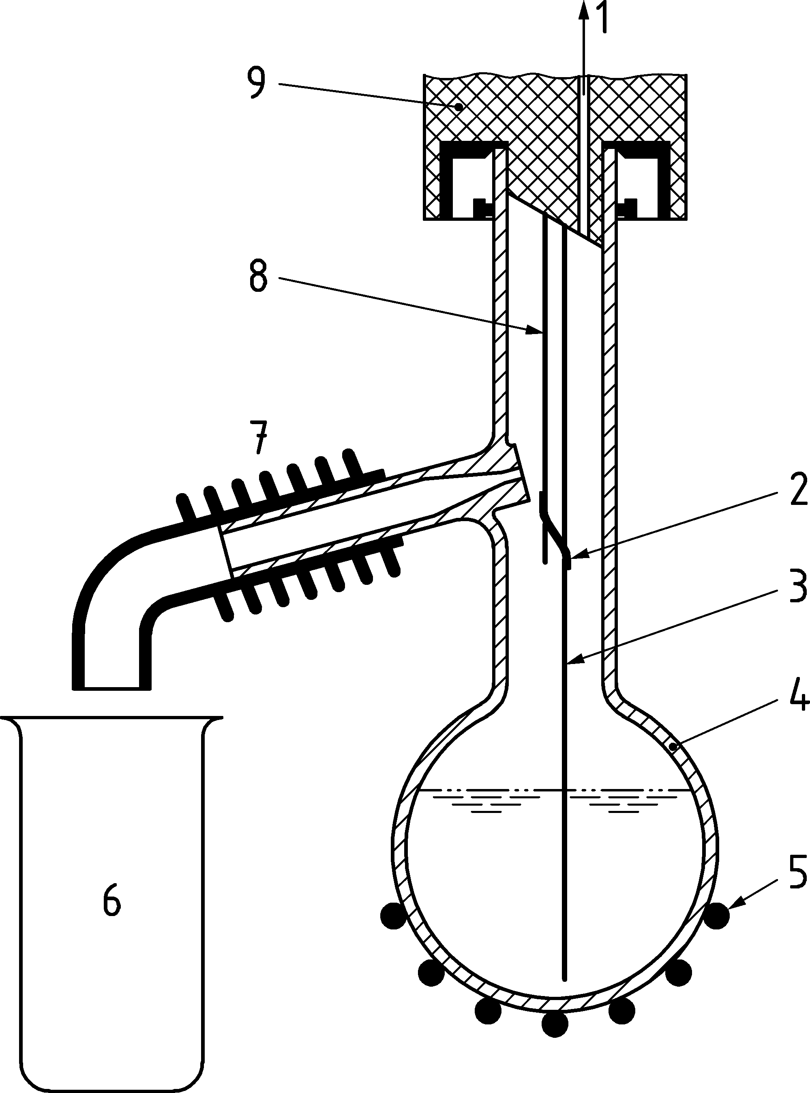

Key

|  |  |  |  |
| --- | --- | --- | --- |
| 1 | to differential pressure sensor (A.1.5.1) | 6 | waste beaker (6.4) |
| 2 | drip tip (A.1.4) | 7 | condensate recovery area (A.1.10) |
| 3 | liquid temperature sensor (A.1.3.2) | 8 | vapour temperature sensor (A.1.3.1) |
| 4 | distillation flask (A.1.6) | 9 | distillation measurement head (A.1.2) |
| 5 | flask heater (A.1.7) |  |  |

Figure A.1 — Schematic of Micro distillation apparatus

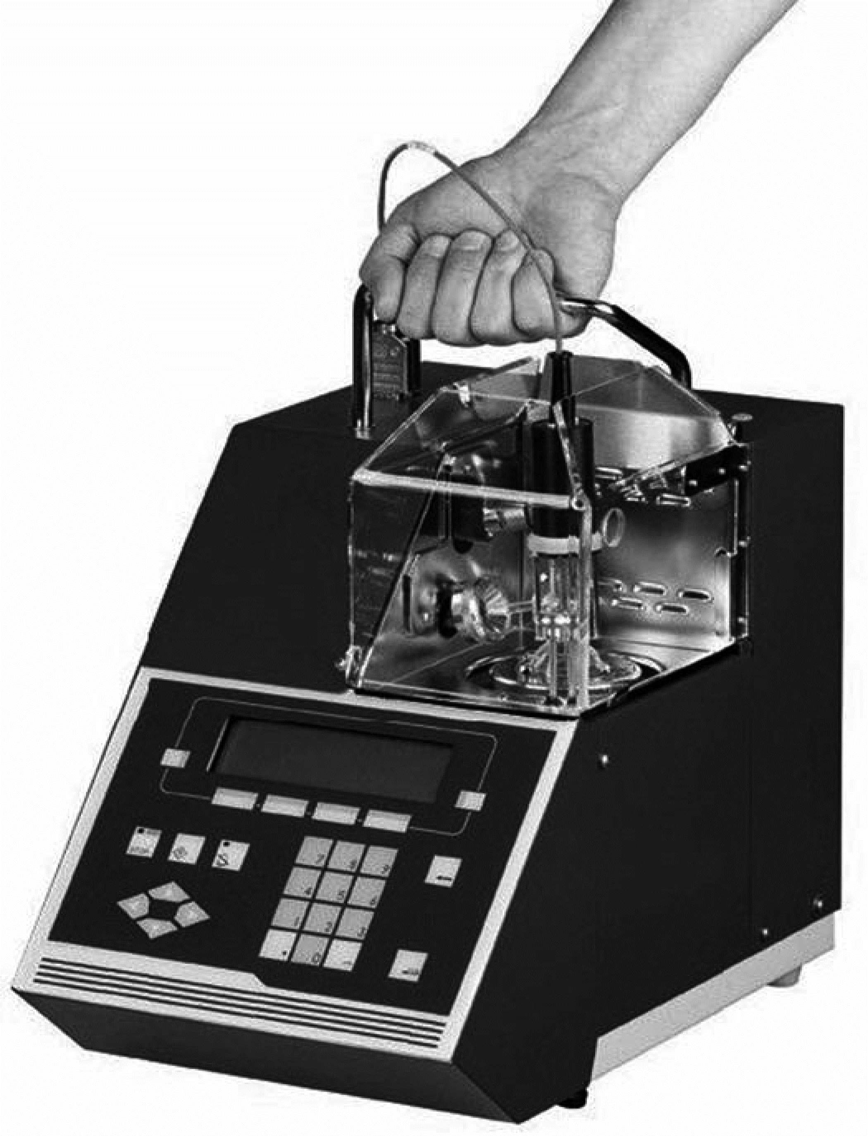

Figure A.2 — Micro distillation apparatus (example)

**A.1.3 Temperature measuring devices**

**A.1.3.1 Vapour temperature sensor***—*Capable of reading to 0,1 °C over the range 0 °C to 550 °C with maximum error ± 0,5°C. The bottom of the sensor shall be positioned approximately 8 mm below the sidearm opening and near the centre of the distillation flask neck.

**A.1.3.2 Liquid temperature sensor***—*Capable of reading to 0,1 °C over the range 0 °C to 550 °C with maximum error ± 0,5°C. The bottom of the sensor shall be positioned approximately 2 mm above the distillation flask bottom.

NOTE K-type thermocouple encased in metal tube was found suitable for this purpose.

**A.1.4 Drip tip** — Special mechanical device protecting vapour temperature measurement device from excessive reflux flow.

**A.1.5 Pressure measuring devices**

**A.1.5.1 Differential pressure sensor** *—* Comprised of a pressure line and electronic pressure transducer capable of measuring the differential pressure in the range from 0 Pa to 2 500 Pa with the resolution of 0,1 Pa and a maximum error of ± 1 Pa.

**A.1.5.2 Ambient pressure measuring device** *—* Comprised of an electronic pressure transducer capable of measuring the ambient pressure where the apparatus is housed in the range 73,33 kPa to 106,7 kPa with an accuracy of 0,1 kPa or better.

**A.1.6 Distillation flask** — Special micro-distillation flask made of heat resistant glass and constructed to the dimensions and tolerances shown on Figure A.3. The accuracy of the test method is related to distillation flask quality. Set tolerances shall be respected.

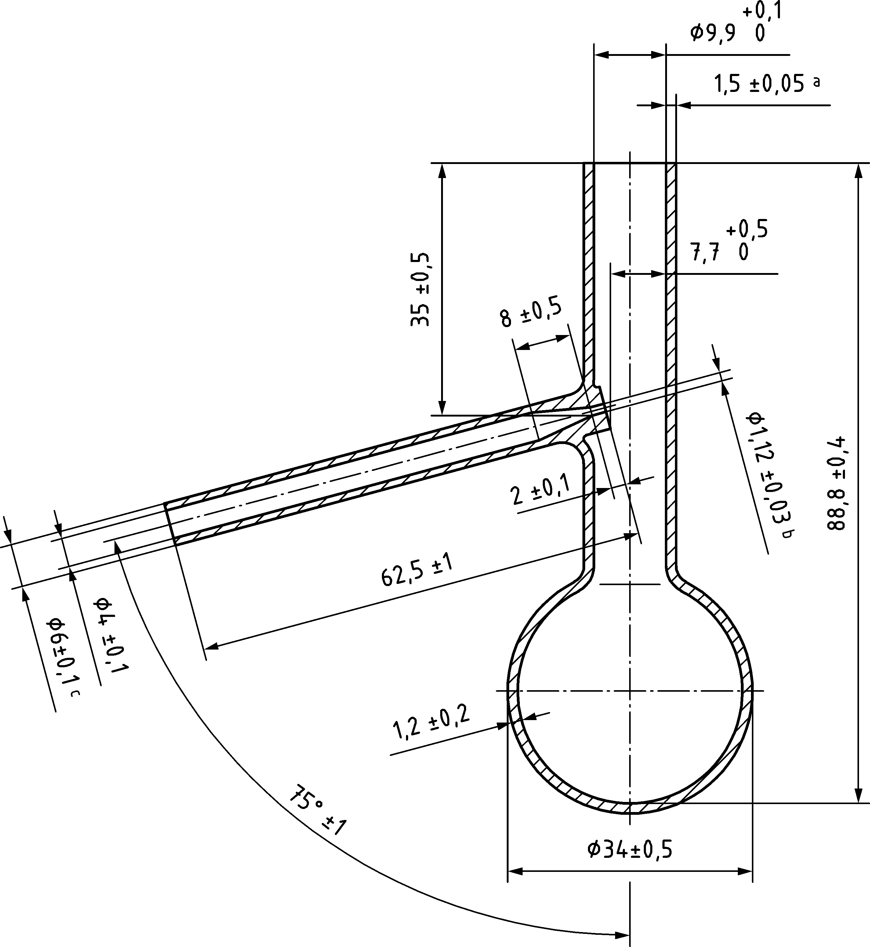

Figure A.3 — Micro Distillation Flask (dimensions in mm)

**A.1.7 Flask heater** — Specially designed electric low voltage, low mass heating element positioned below the distillation flask on a movable platform and capable to supply necessary heat power and supporting the distillation flask during the test.

**A.1.8 Control systems** — Automatic controlling system capable of monitoring the collected distillation data, applying adjustments to the heating system, controlling safe and proper operation of apparatus during whole distillation run and determining the termination of the distillation.

**A.1.9 Data processing systems** — Automatic data processing system capable of conversion of the collected distillation data into industry recognized distillation report format, correction of data for barometric pressure, with provisions for display of report or printing/transfer of report, or both.

**A.1.10 Condensate recovery area** — Air-cooled condensate tube with provision for collection of condensed distillate and drain it to a waste beaker.

1. (normative)  
     
   Precision of the volume percent evaporated or recovered at a prescribed temperature

**B.1** The precision of the volume % evaporated or recovered at a prescribed temperature for Test Method of this document were derived according to EN ISO 4259 [8] from a 2005 interlaboratory program.

**B.2** Precision for Volume % Evaporated for Petrol:

Consolidated equation for valid range of E70 to E180°C.

|  |  |  |
| --- | --- | --- |
|  | *r* | *R* |
| Micro Dist | 0,0216[(20 + *X*) (100– *X*)]0,5 | 0,0410 [(20 + *X*) (100 – *X*)]0,5 |

where

|  |  |
| --- | --- |
| *X* | percent evaporated at the prescribed temperature. |

**B.3** Precision for Percent Recovered for Diesel:

Consolidated equation for valid range of R180 to R350°C.

|  |  |  |
| --- | --- | --- |
|  | *r* | *R* |
| Micro Dist | 1,11 | 1,74 |

**B.4** Relative bias for volume percent evaporated or recovered at a prescribed temperature.

Results on the same materials produced by this test method and EN ISO 3405 have been assessed with methodology outlined in ASTM D 6708 [7].

**B.4.1** Petrol: The biases were generally small, though they were statistically significant in some cases and may not be random. It should be noted that the data set available is limited and conclusions are suggestive, the differences were mainly observed during the first portion of the distillation where the evaporation loss occurs due to the sample volatility and handling which is difficult to control.

**B.4.2** Diesel: The biases were generally small and not correctable, and there are some sample specific bias. It should be noted that the data set available is limited in some cases and conclusions are suggestive.

1. (informative)  
     
   Typical samples

Typical samples and group classification are given in Table C.1 and C.2.

Table C.1 — EN ISO 3405 groups

|  |  |  |  |  |
| --- | --- | --- | --- | --- |
| **Sample characteristics**  **Distillate type** | **Group 1** | **Group 2** | **Group 3** | **Group 4** |
| Vapor pressure at 37,8 °C, kPa | ≥ 65,5 | < 65,5 | < 65,5 | < 65,5 |
| Distillation, IBP, °C |  |  | ≤ 100 | > 100 |
| Distillation, EP, °C | ≤ 250 | ≤ 250 | > 250 | > 250 |

Table C.2 — Typical samples types of EN ISO 3405 Groups

|  |  |  |  |  |
| --- | --- | --- | --- | --- |
|  | **Group 1** | **Group 2** | **Group 3** | **Group 4** |
| Petrol | X | X |  |  |
| Aviation Petrol | X | X |  |  |
| Diesels |  |  |  | X |
| FAME Blends |  |  |  | X |
| Fuel Oils |  |  |  | X |
| Kerosene |  |  |  | X |
| Turbine Fuels Jet A, A1 JP8, JP5 |  |  |  | X |
| Turbine Fuels Jet B |  |  | X |  |
| Distillate Marine Fuels |  |  |  | X |

Bibliography

[1] ASTM D 7345, Standard Test Method for Distillation of Petroleum Products and Liquid Fuels at Atmospheric Pressure (Micro Distillation Method)

[2] ASTM D 1160, Standard Test Method for Distillation of Petroleum Products at Reduced Pressure

[3] ISO Guide 35, Reference materials — Guidance for characterization and assessment of homogeneity and stability

[4] ASTM RR:D02-1621, *An interlaboratory study was conducted by laboratories which tested thirty-three materials to establish the precision statement of test methods D86, D7345, and D7344*

[5] ASTM RR:D02-1831, *An interlaboratory study was conducted by laboratories which tested twenty-one materials to establish the precision statement for petrol and petrol-ethanol blends of test method D7345*

[6] ASTM RR:D02-1794, *An interlaboratory study was conducted by twenty-two laboratories testing eleven samples to establish a precision statement for test method D7345 and D1160*

[7] ASTM D 6708b, Standard Practice for Statistical Assessment and Improvement of Expected Agreement Between Two Test Methods that Purport to Measure the Same Property of a Material

[8] EN ISO 4259:2006, Petroleum products — Determination and application of precision data in relation to methods of test